PSF
Parents, please tell your child the following words, and have them “robot” speak the sounds of each word.
  - Example: Tell them the word cat. They must say each sound as (like a robot separating each sound): /c/ /a/ /t/
  - Chair: /ch/ /ay/ /r/
  - Swing: /s/ /w/ /ee/ /ng/
  - Tracks: /t/ /r/ /a/ /k/ /s/

- Dog /d/ /o/ /g/

- Bug /b/ /u/ /g/

- Sit /s/ /i/ /t/ 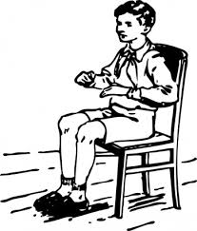

- Mat /m/ /a/ /t/

- Win /w/ /i/ /n/

PSF
Parents, please tell your child the following words, and have them “robot” speak the sounds of each word.
  - Example: Tell them the word cat. They must say each sound as (like a robot separating each sound): /c/ /a/ /t/
  - Chair: /ch/ /ay/ /r/
  - Swing: /s/ /w/ /ee/ /ng/
  - Tracks: /t/ /r/ /a/ /k/ /s/
- Can /c/ /a/ /n/

- Pig /p/ /i/ /g/

- Hot /h/ /o/ /t/

- Leg /l/ /e/ /g/ 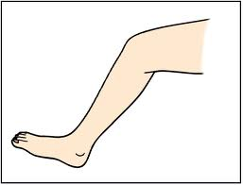

- Rug /r/ /u/ /g/

